"How do emotions play?"
Classes about emotions

1. Welcoming the children
2. Integration fun with the use of the song "Now there will be such magic"
(SuperSmyki, Level B, CD1, 5 and 6) in the case of an odd number of children, the teacher also takes part. We repeat the song twice, each time the children form different pairs.
3. How are you today and why? - well-being conversation, children define their mood and try to justify.
4. We get to know emotions - working with illustrations, naming individual emotions. Converting illustrations.
5. Instruments - listening to the sound of individual instruments.
6. Assigning a given instrument to a picture of emotions.

• Cymbalks - surprise
• Rattle - love
• Tambourine - sadness
• Janczary - joy
• Bell - fear
• Piano - anger
• Knocker - disgust

7. We play with emotions - reacting to the sound of the instrument by showing an appropriate emotion

8. We create emotions - pegging faces with individual emotions using blocks.

9. Our smileys talk to us - using ChatterKid, creating a smiley that speaks to children.

10. Summarizing the classes, repeating the collected information.

Task 8. 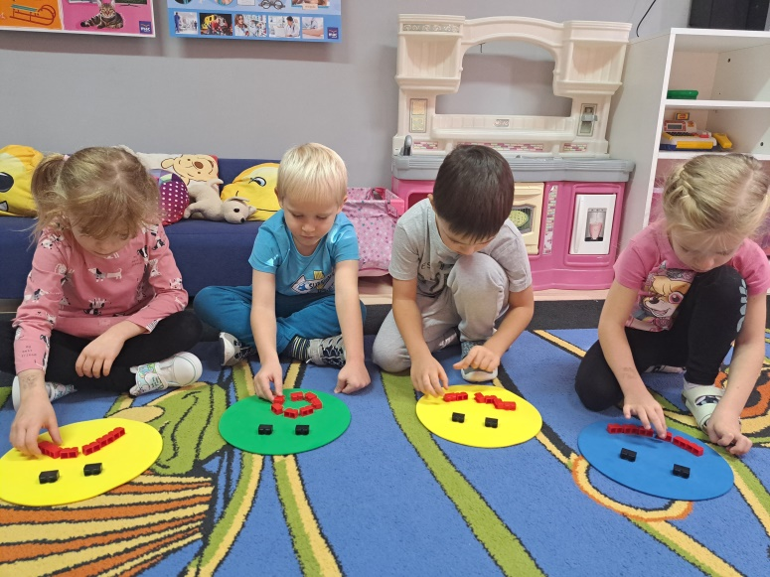

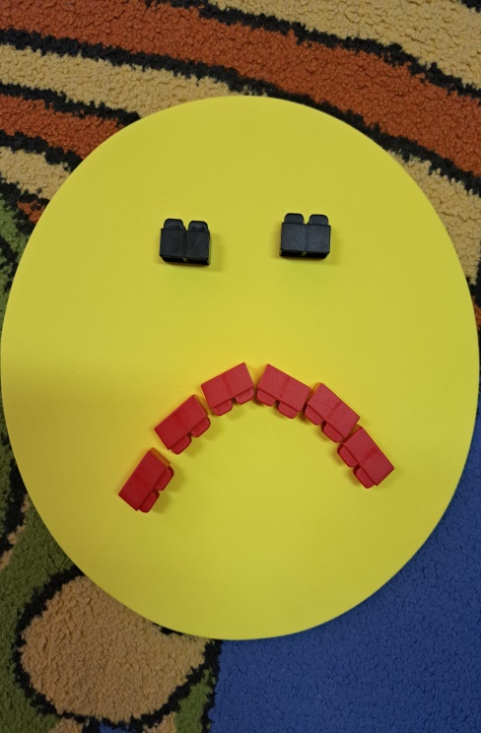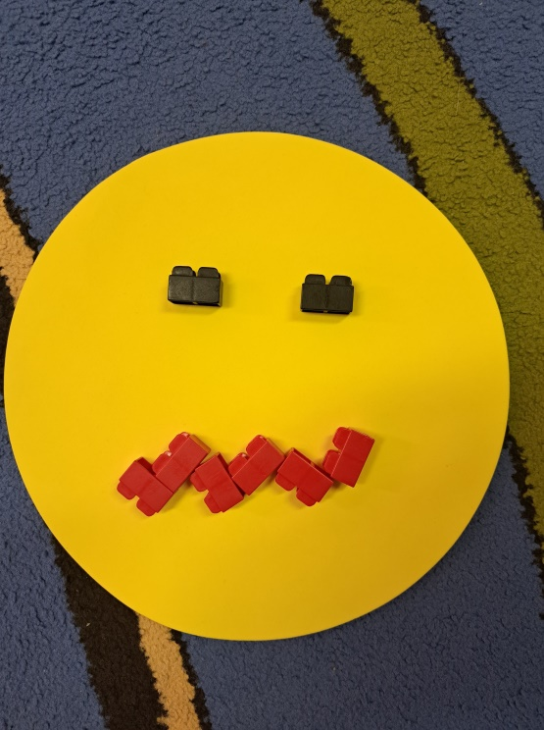
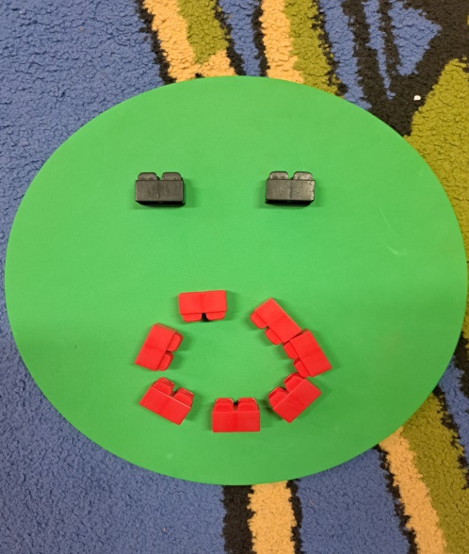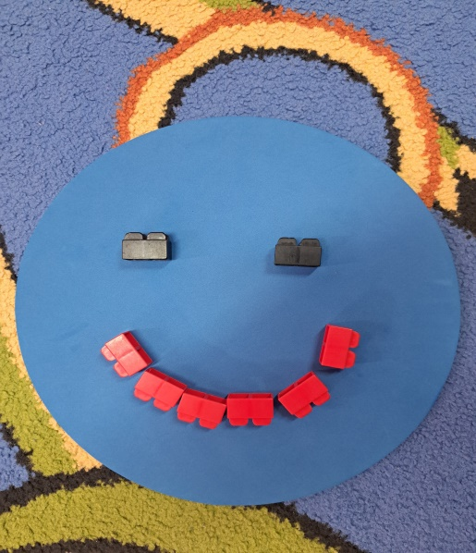

task 7.
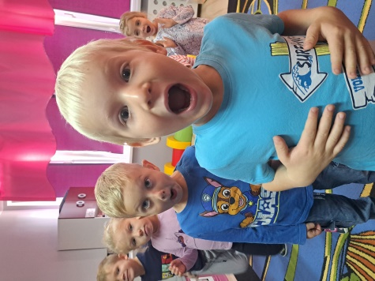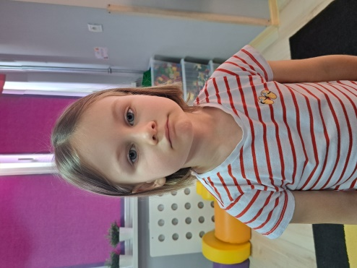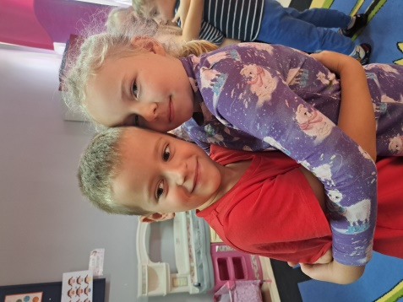

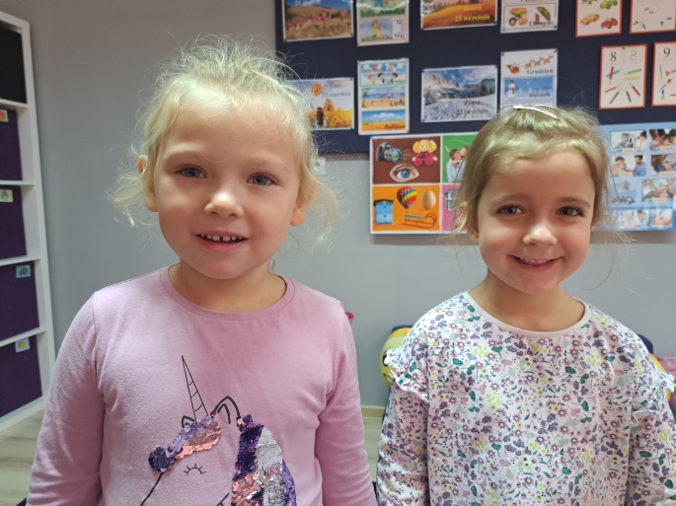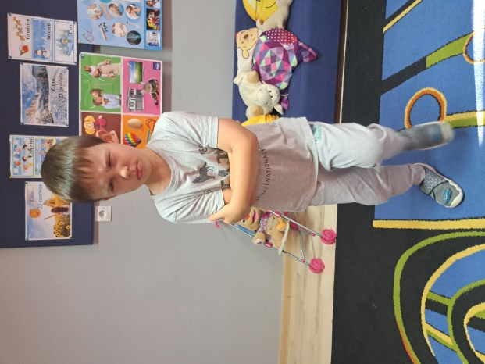
Astonishment, sadness, love, joy, anger

task 6.
