LESSON IDEAS

Activities for
4 - 5 year olds
Junior Infants

Teachers: Antonella Martorana- Giovanna Catalano
Age group: 4-5 years old
Time: 30 minutes

Nature is full of mathematical wonders and patterns. As we step into the theme of gardening, we can appreciate the mathematical beauty of nature as we explore foundational skills for our preschoolers

The theme of the lesson:
"Shape garden "
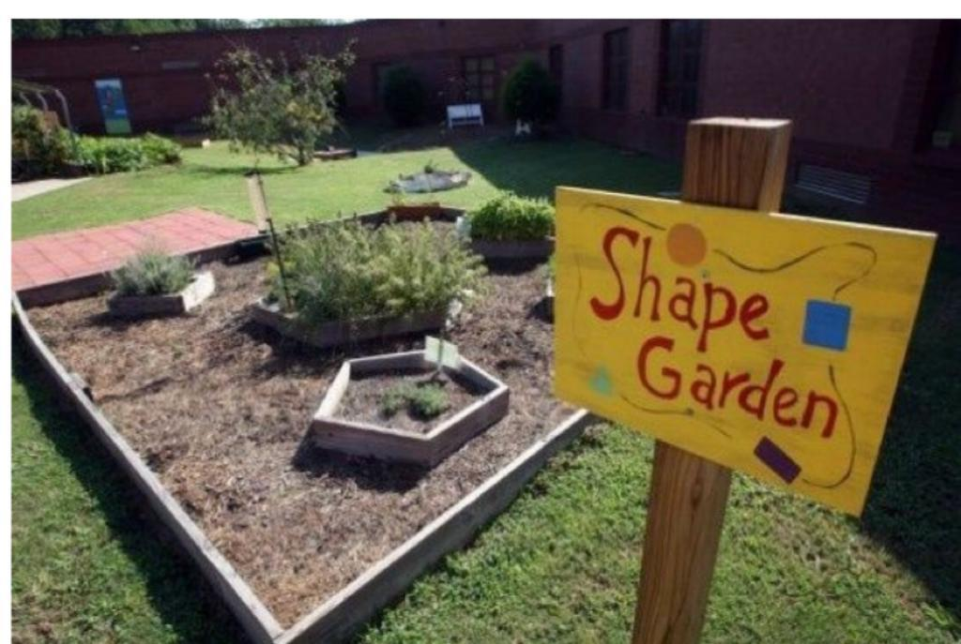

Outline of the activity:
1. Greeting with a song: https://www.youtube.com/watch?v=Cd2O4utPw6c

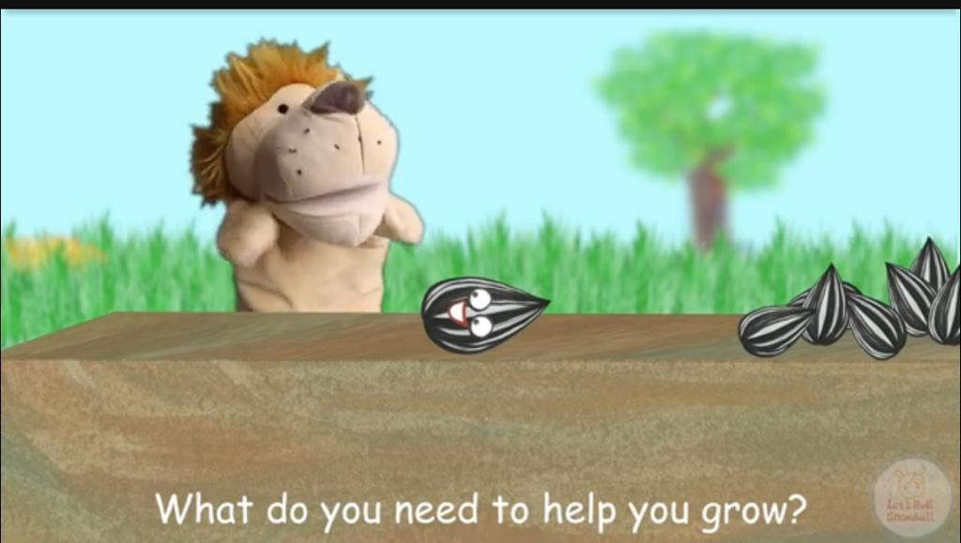

2.Building in the garden 2 geometric shapes: a triangle and a square

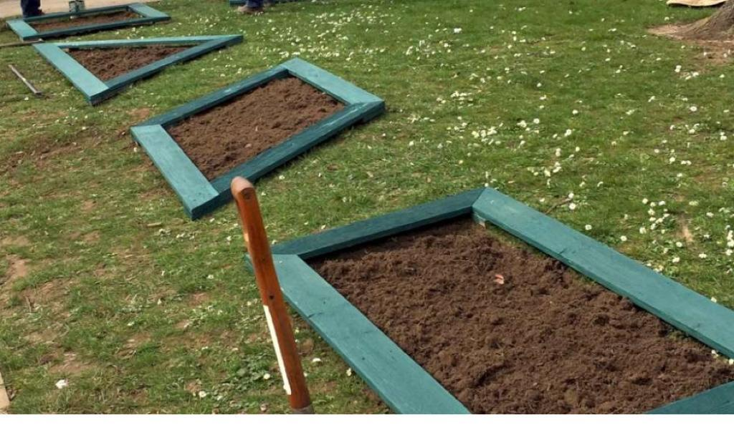
3. Sow 2 types of seeds, one type for each shape

Specific goals:
· Count and represent objects
· Compare numbers
· Creating situations for playing together.
· Developing the child's creativity.

Learning Objectives

- Provides hands-on learning in a variety of subjects
- Teaches students to focus and grow in patience, cooperation, teamwork and math skills
- Math (measurement of plants, calculating perimeter …)

Methods: verbal conversations, explanations, practical action
Forms of work: individual, collective.

