LESSON IDEAS

Activities for
5 - 6 year olds

Senior Infants

Teachers: Antonella Martorana- Giovanna Catalano
Age group: 5-6 years old
Duration: 30 minutes

Garden math activities for growing minds

The theme of the lesson: " Seeds and plants”

Outline of the activity:
1. Greeting with a song: https://www.youtube.com/watch?v=Cd2O4utPw6c 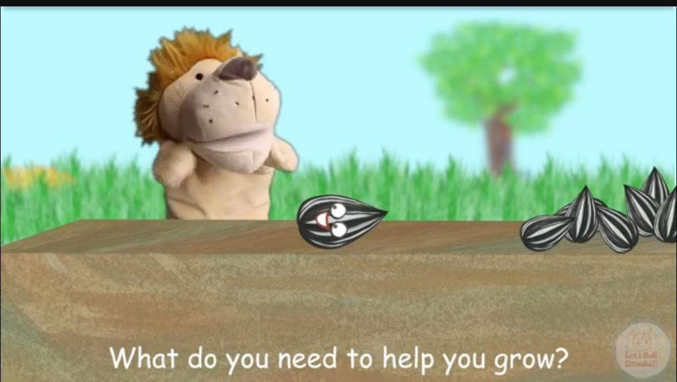

2. Sow some seeds in cardboard jars. (Count the rocks as we pull them out of the soil, count plants….)
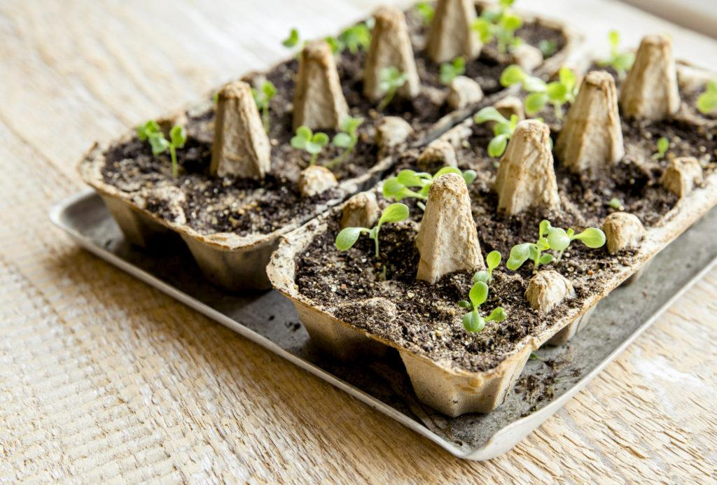

3. Flower bead lacing (fine motor counting)
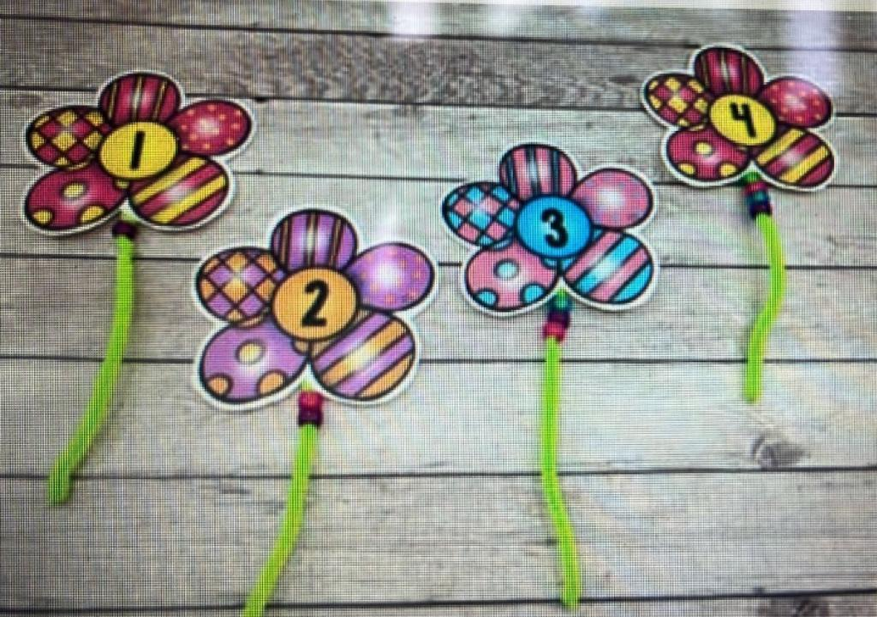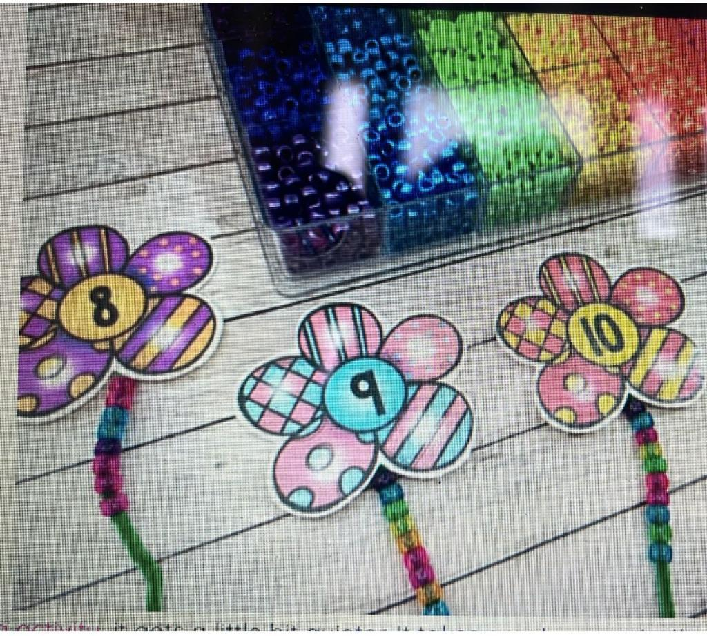
Specific goals:

- Count and represent objects including coins to 10
- Match a quantity with a numeral
- Compare numbers
- Creating situations for playing together.
- Developing the child's creativity.

Learning Objectives

- Provides hands-on learning in a variety of subjects
- Teaches students to focus and grow in patience, cooperation, teamwork and math skills
- Math (measurement of plants, calculating perimeter …)

Methods: verbal conversations, explanations, practical action
Forms of work: individual, collective.

