LESSON IDEAS

Teachers: SABRINA RUVOLO-MANUELA LO SCHIAVO
Age group: 5
Duration: 30 minutes
The theme of the lesson:
" ROBOT AND CODING”
CODING/ MATH ACTIVITIES FOR GROWING MINDS

Outline of the activity:

- Greeting with a song: the robot dance https://youtu.be/Wbb7WddVBqA?si=fU7_8sUPsDzypQQg

- Build “Floppy “the robot with recycled materials (cardboard, buttons…)
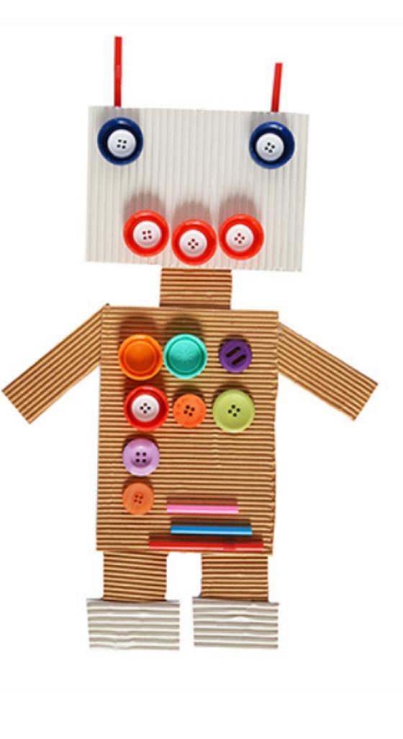
3.Make a square formed by 5 rows and 5 columns by attaching coloured adhesive tape on the floor. Invite the children to move the robot they have built starting from the first box at the top left.

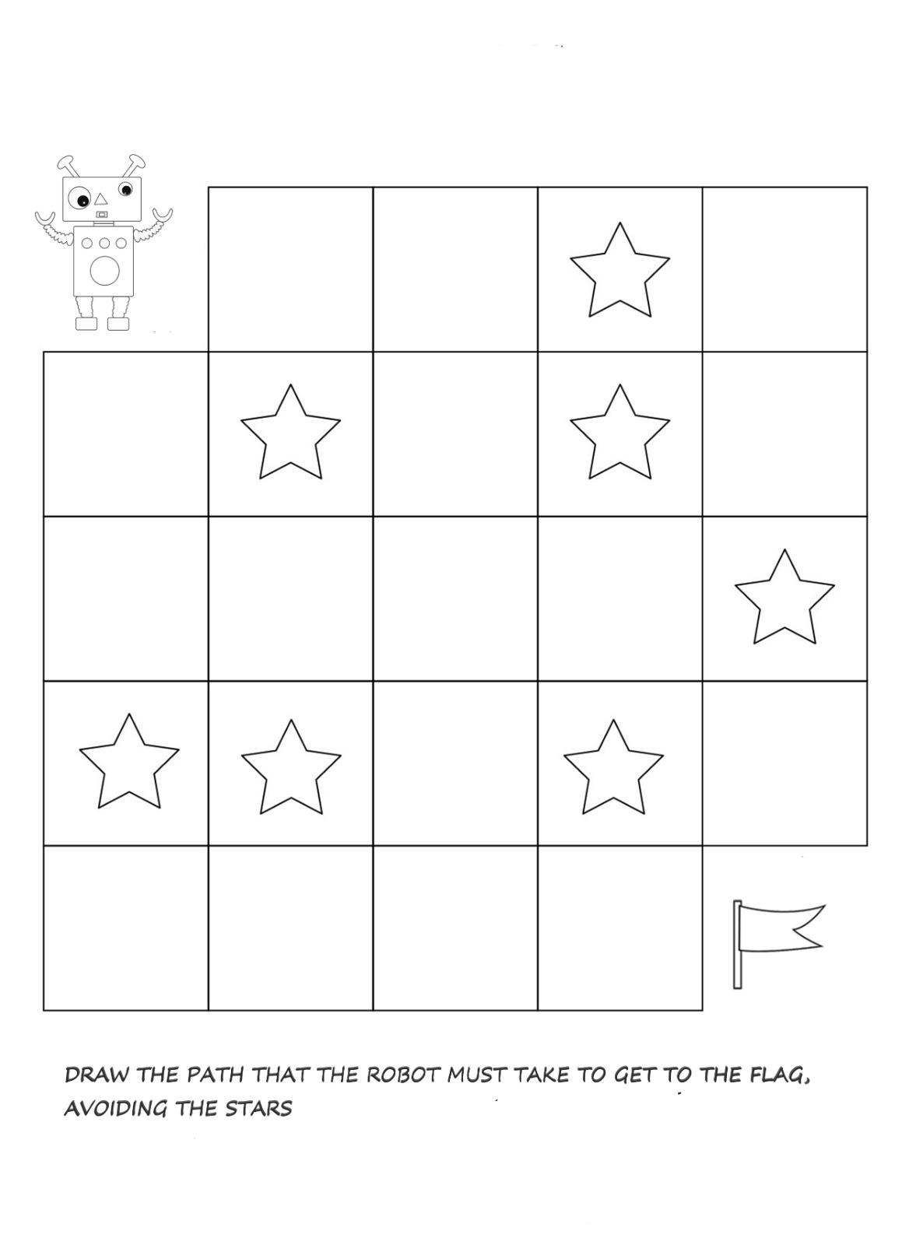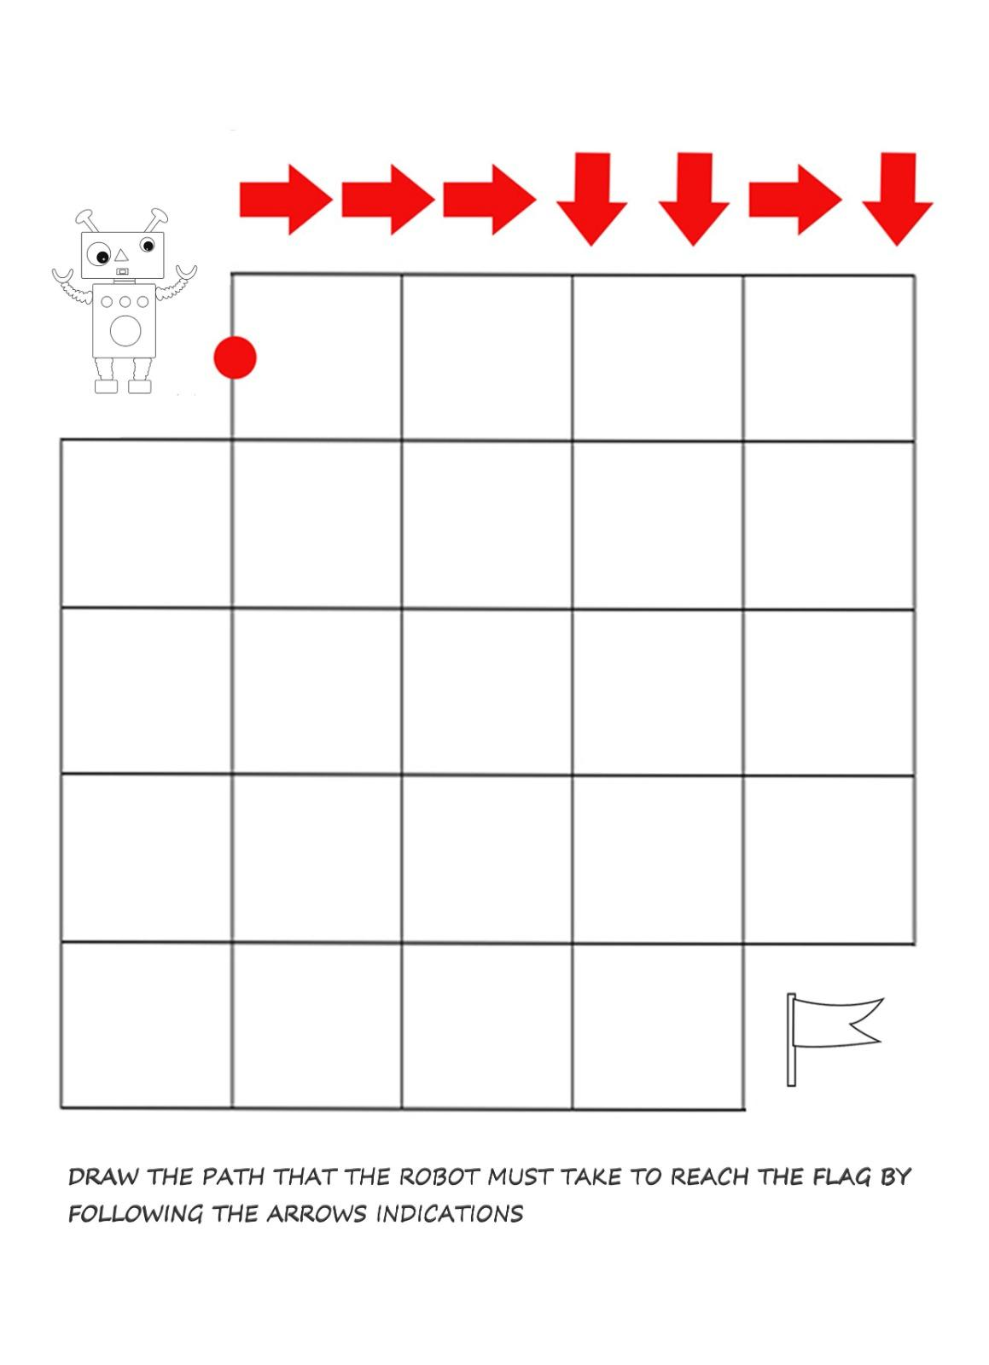

Specific goals:

- logical thinking and mathematical competences
- Creating situations for playing together.
- Provides hands-on learning in a variety of subjects
- Teaches students to focus and grow in patience, cooperation, teamwork and math skills

Methods: verbal conversations, explanations, practical action Forms of work: individual, collective.

Necessary materials:
Crayons, scissors, paper, coloured adhesive tape, bottons, cardboard, glue,
coloured paper

