LESSON IDEAS n.2

Teachers: MANUELA LO SCHIAVO- SABRINA RUVOLO
Age group: 5
Duration: 30 minutes
The theme of the lesson:
" BUNNY RABBIT AND CODING”

Outline of the activity:

- Greeting with a song: “Rabbit dance”
https://www.youtube.com/watch?v=TT8WFm-GxR4

- Make a square formed by 5 rows and 5 columns by attaching coloured adhesive tape on the floor. Invite the children to take the carrots starting from the first box at the top left.

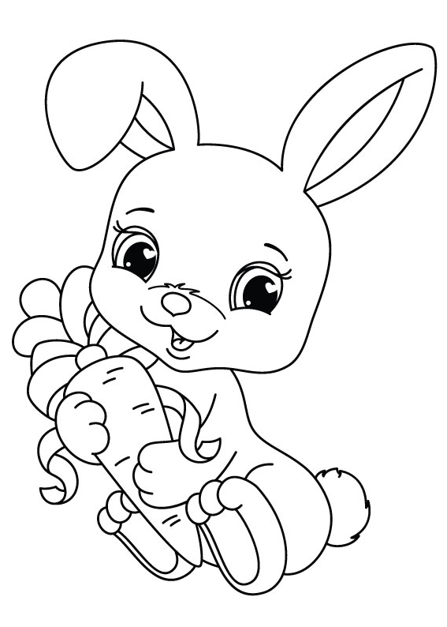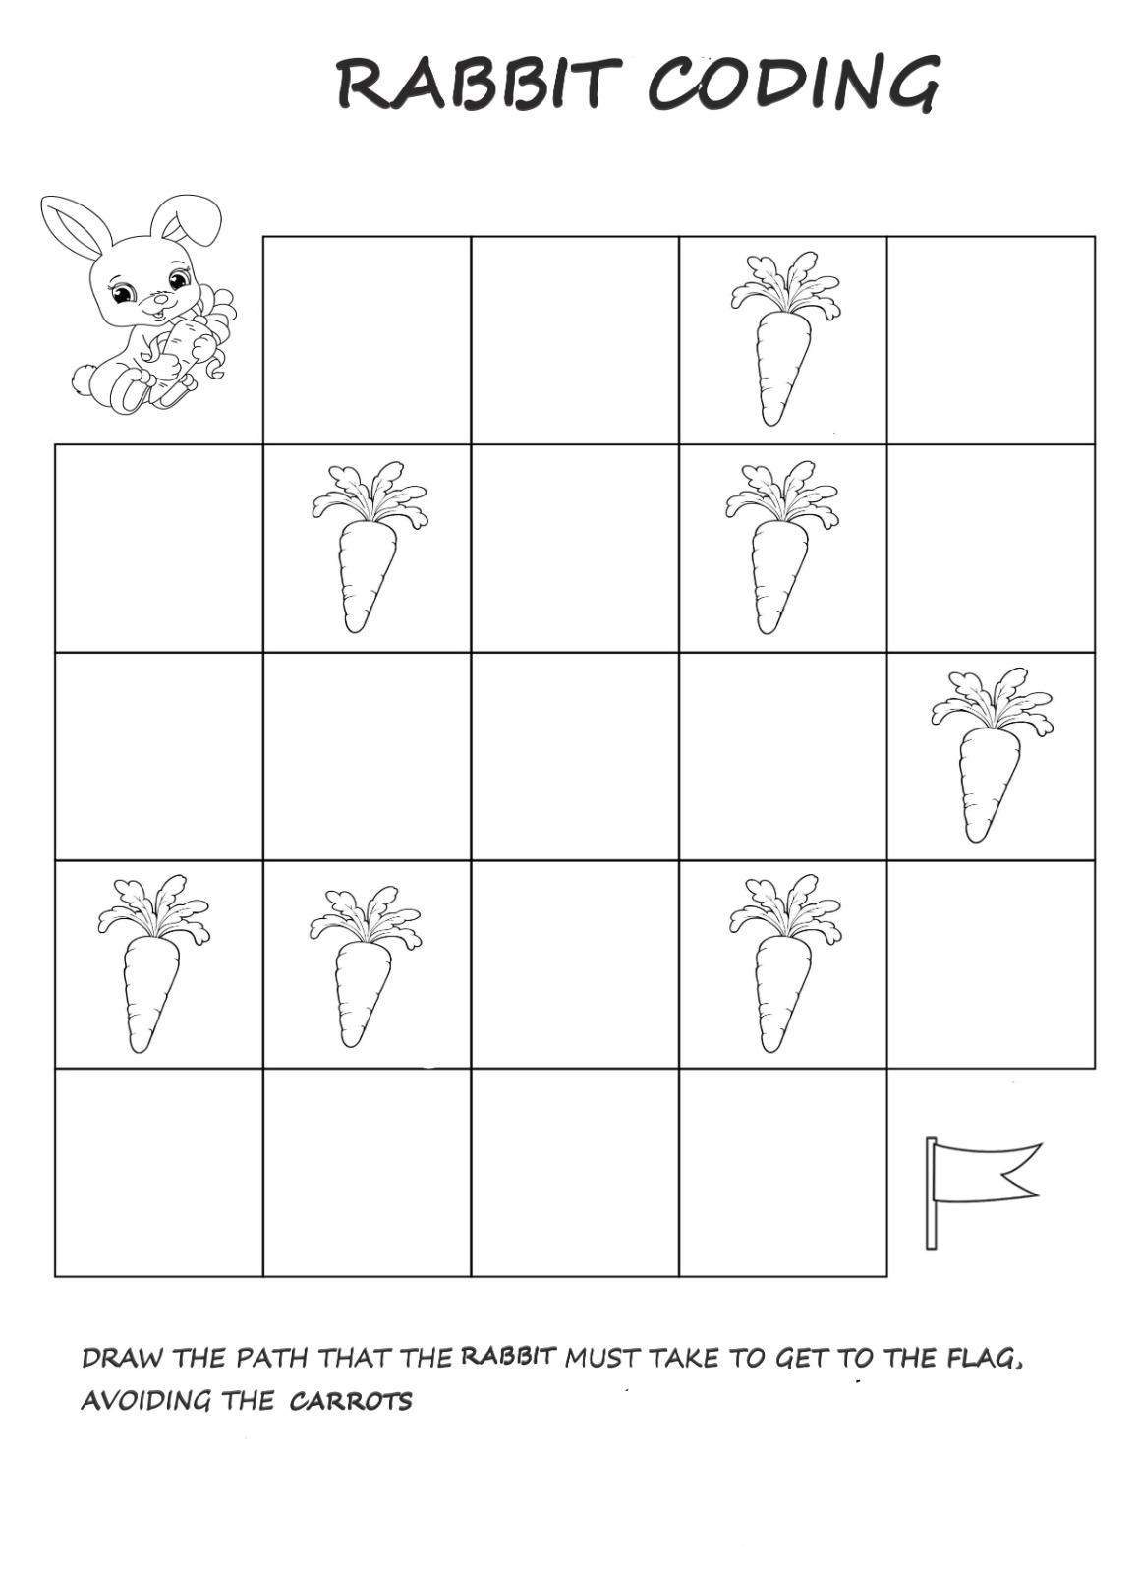
- Basic coding game using digital boards:

google doodle game coding rabbit

Specific goals:

- logical thinking and mathematical competences
- Creating situations for playing together.
- Provides hands-on learning in a variety of subjects
- Teaches students to focus and grow in patience, cooperation, teamwork and math skills

Methods: verbal conversations, explanations, practical action Forms of work: individual, collective
Necessary materials:
Crayons, scissors, paper, coloured adhesive tape, bottons, cardboard, glue,
coloured paper, digital boards

