LESSON IDEA
DEVELOPING MATHEMATICAL COMPETENCES AND LOGICAL THINKING
USING BOARD GAMES AND CODING
FOR CHILDREN AGED 3-4
Topic: We know geometric figures well
Teacher: Anna Czapnik

General goals:
• consolidating the basic qualitative features of geometric figures: triangle, circle, square, rectangle;
• improving the perception and recognition of the shape of geometric figures;
• developing the correct response to visual and auditory signals;
• arousing interest in artistic compositions made of simple geometric figures;
• practicing visual analysis and synthesis,
• developing perceptiveness and concentration of attention;
• compliance with agreements applicable in the game;

Working methods:
• active (method of tasks given to the child, method of independent experiments, method of exercises);
• verbal (conversation, explanations).

Forms of work: individual, team, collective.

Teaching resources:
• geometric figures (circle, square, triangle, rectangle) cut out of cardboard, a CD with a composition by Batia Strauss, gymnastic bags, boards showing compositions made of colorful sticks, illuminated panels, boards of geometric figures with a marked path.

Course of classes:

1. A thread of understanding – an introductory game that integrates the group.
Children sit in a circle. They hold hands. The teacher says a poem: I release the spark of friendship into the circle, let it return to my hands.

2. Figures – a game that reminds and consolidates the appearance and names of geometric figures.
Children sit in a circle on the carpet. N. assigns them individual geometric figures (circle, triangle, square, rectangle). At the agreed sign, giving the name of a given figure, the children with this figure get up, run around the seated people once and return to their places. When the word is: all figures, everyone gets up and rotates around their axis.

3. Coding figures - geometric figures glued to the carpet, one of the children stands at the start, the other child with a board on which the path is marked leads the friend. We repeat the game in pairs.
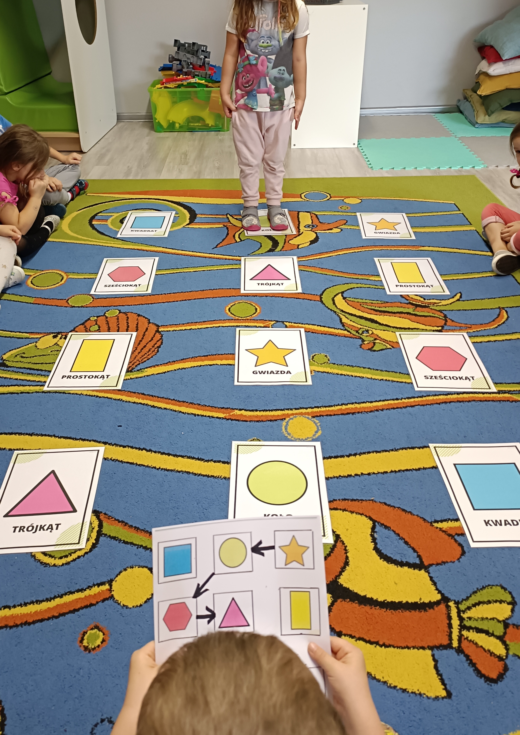
4. Musical game with bags according to Batia Strauss's methods - tapping rhythms and following established rules in play.

5. Arranging compositions of colorful sticks on illuminated panels

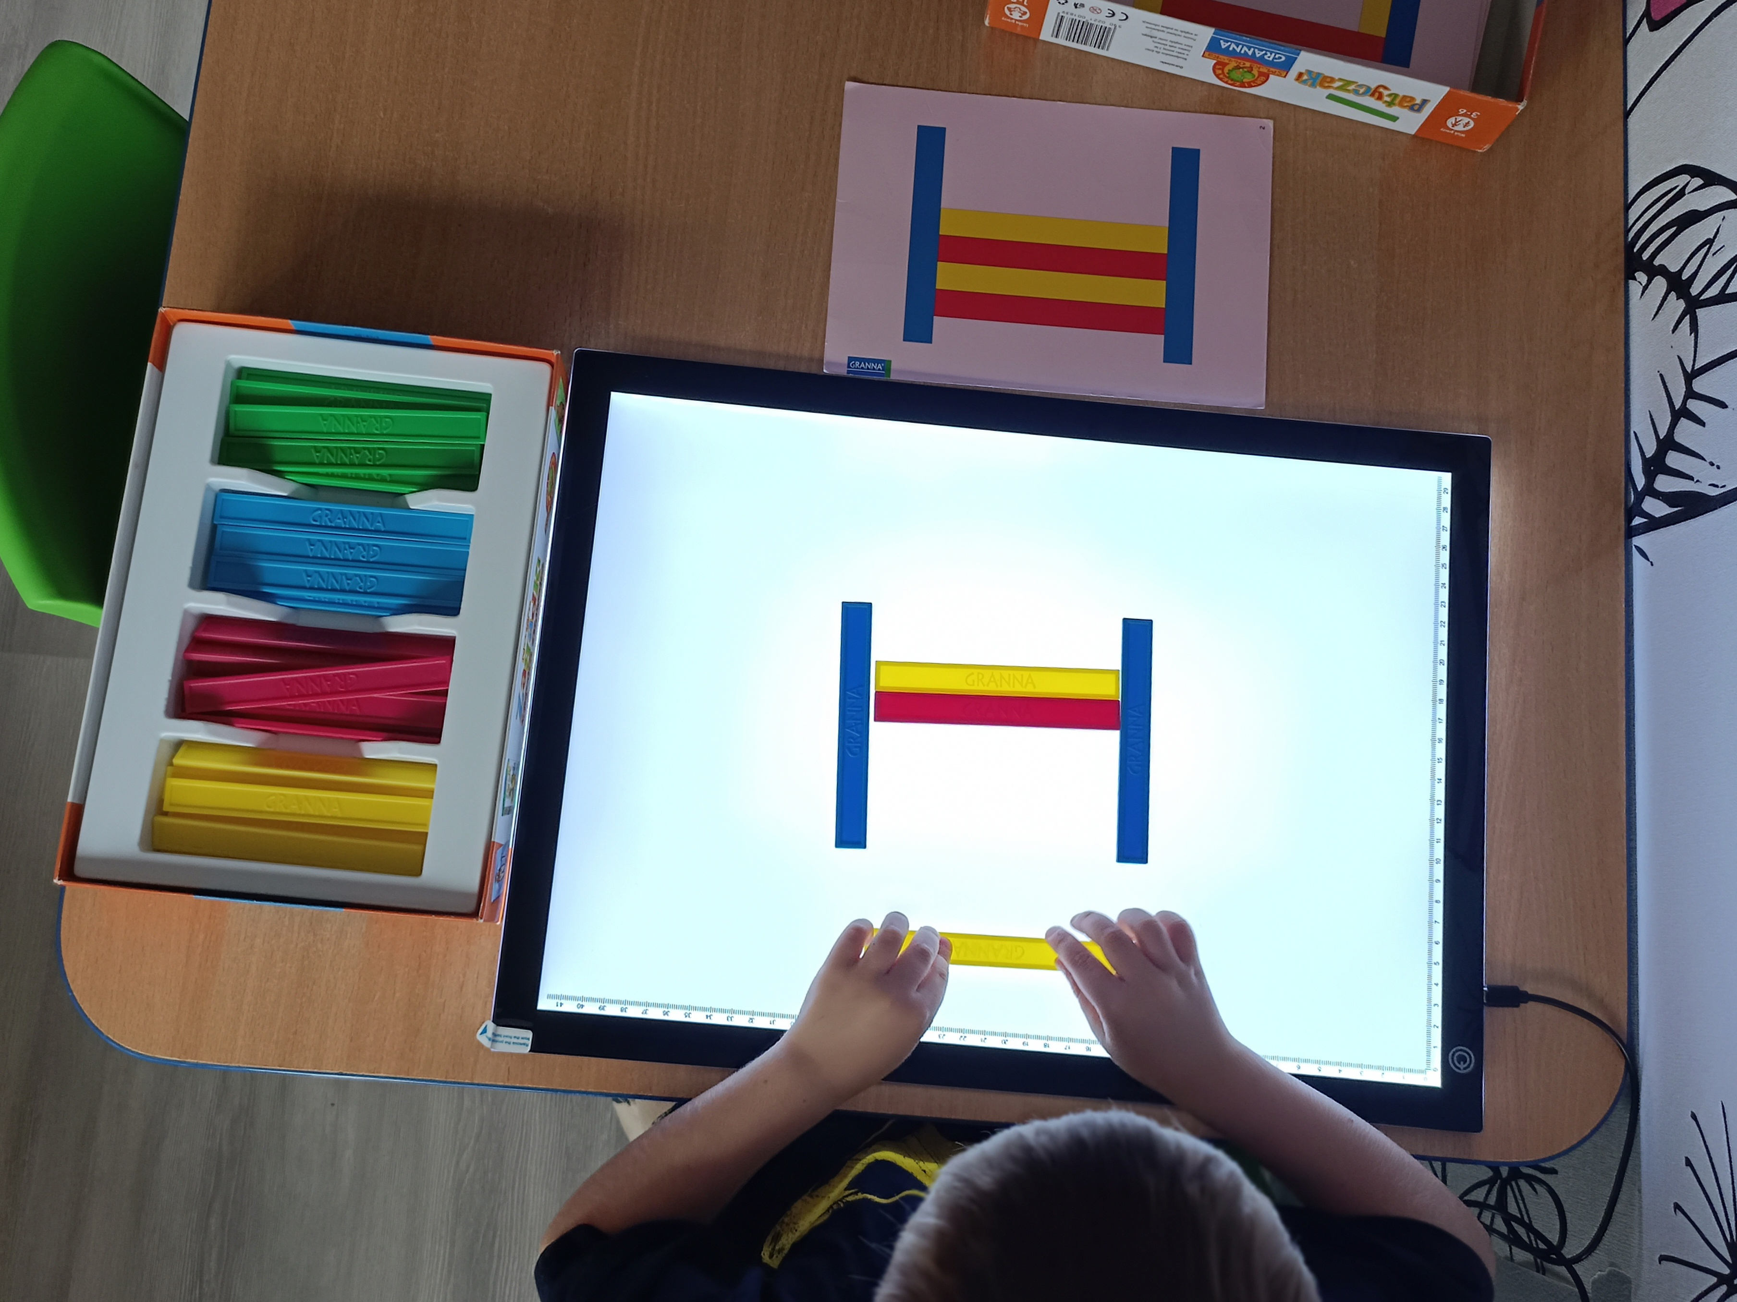
6. Ending - singing the song in English "Big Wheels"

